Gas Leakage Detector Using 8051 Microcontroller with LCD Display

**Prepared by:** DEERAJ V

**Roll Number:** 23EE011

**Branch:** B.E/EEE

# Abstract

This project presents a simple and effective embedded system for gas leakage detection using an 8051 microcontroller (AT89C51) and an LCD display, with simulation carried out in Proteus. The system continuously monitors the environment for LPG (Liquefied Petroleum Gas) or similar gases using a gas sensor (e.g., MQ series). When gas leakage is detected, the system immediately displays an alert message on the LCD, prompting necessary safety actions. This prototype serves as an excellent learning tool for understanding gas sensor interfacing, real-time monitoring, and embedded C programming for microcontrollers, while also demonstrating the practical integration of sensor data with visual feedback.

# Introduction

In many residential, commercial, and industrial environments, gas leakage poses serious safety risks. Early detection is crucial to prevent hazards such as fires, explosions, and health issues. Automating gas detection enhances safety and ensures timely alerts without relying on manual monitoring. This project uses an 8051 microcontroller (AT89C51) to continuously monitor the presence of gas through a gas sensor (e.g., MQ series). When a leak is detected, a warning message is immediately displayed on a 16x2 LCD screen, prompting occupants to take quick action and avoid potential danger. The system offers hands-on experience in sensor interfacing, real-time embedded control logic, and hardware display integration. It serves as a practical introduction to embedded system design focused on safety applications and provides a strong foundation for developing more advanced automated safety solutions.

# Working Principle

* The gas sensor (e.g., MQ series) continuously monitors the surrounding air for the presence of gases like LPG.
* The sensor outputs a digital HIGH signal when the gas concentration crosses a certain threshold level, indicating a leak.
* The 8051 microcontroller (AT89C51) reads this digital signal from the gas sensor through a dedicated input pin.
* When the sensor output is HIGH (gas detected), the microcontroller immediately triggers a warning on the 16x2 LCD display.
* The LCD displays clear messages such as "Gas Detected!" and "Take Action!" to alert the user.
* If no gas is detected (sensor output LOW), the system displays "No Gas Present" and "System Normal" messages on the LCD.
* The system operates continuously in real time, providing instant updates based on sensor input.
* This approach ensures quick detection and visual warning without manual checking, improving safety and reliability.

# Circuit Diagram and Output

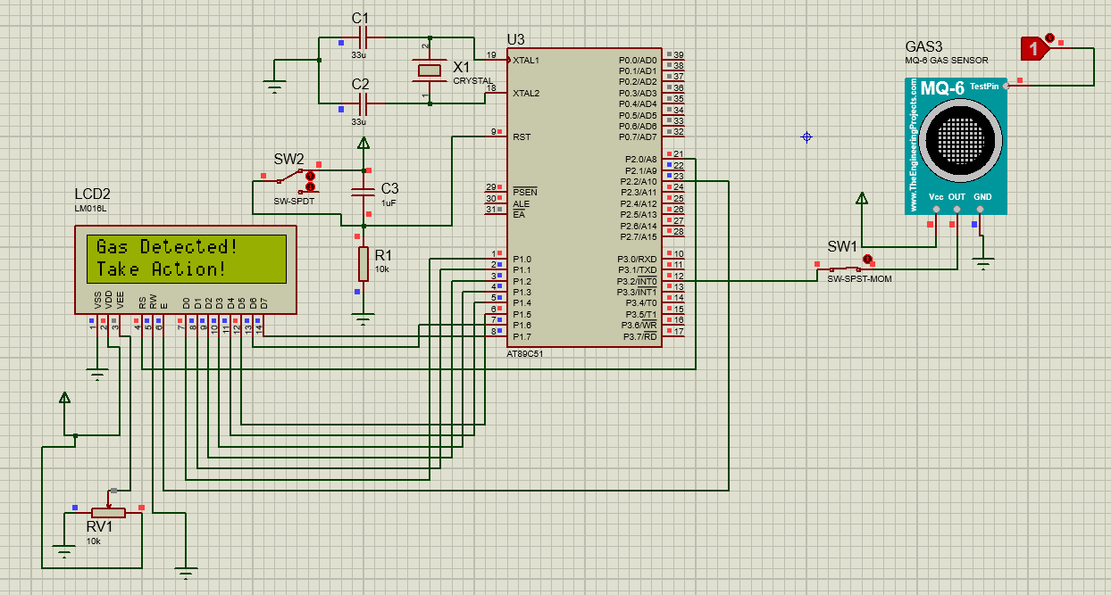

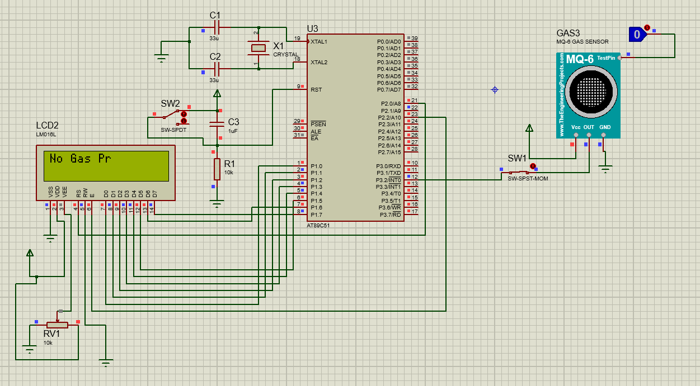

## Application

• Smart home safety systems for LPG or flammable gas leak detection.  
• Industrial gas storage and handling safety monitoring.  
• Kitchen safety devices for early gas leak alerts.  
• Embedded systems education and practical lab projects.  
• Automated gas detection systems in hotels, hospitals, and commercial buildings.

## Future Scope

• Integrate a GSM or Wi-Fi module to send SMS or app notifications during gas leakage.  
• Upgrade the 16x2 LCD to an OLED or graphical LCD for more detailed live gas concentration display.  
• Connect to IoT platforms like Blynk or Firebase for remote monitoring and data logging.  
• Add an automatic cut-off system to shut down valves or appliances when gas is detected.  
• Design a compact, durable enclosure for real-world deployment and better protection.

## Appendix

• Gas Sensor Block – Detects presence of LPG or flammable gases and outputs signal.  
• Microcontroller Processing Block – Reads sensor data and executes control logic.  
• LCD Display Block – Provides real-time visual status updates to users.  
• Power Supply Block – Ensures stable operation of sensor and microcontroller circuits.  
• Simulation & Validation Block – Allows testing using Proteus before real hardware deployment.  
• Interconnect Lines – Establish connections among sensor, microcontroller, and display for seamless operation.

## Conclusion

This project successfully demonstrates a gas leakage detection and alert system using an 8051 microcontroller, ensuring timely warning in case of hazardous gas presence. By integrating a gas sensor with real-time LCD display alerts, the system enhances safety without requiring constant human monitoring. The design provides a solid foundation for understanding embedded safety systems and sensor-based monitoring.